

Figure 1.1



Figure 1.2

It appears that the last quarter was substantially more variable than the first. Interestingly though, look at the spike in the S&P in the first few days of the year! I wonder if this is a regular phenomenon!



Figure 2

Look at how dramatically the daily low score had increased by the end of the month! High scores also became less variable and saw a slight score increase as well.

Figure 3

Obviously temperatures in July (summer) will be much higher (even when averaged) than in January (winter). However, it looks like temperatures in the city were pretty different depending on what part of the city you were in during January. There were approximately 20-25 degree differences in mean temperature between NE/N Cntrl and South/West.

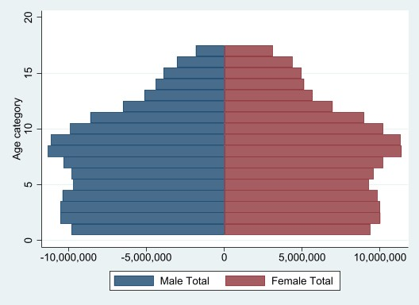

Figure 4

I’m curious about the age categories here. Are we only looking at people as old as 20? I doubt it. I think instead that the elderly are the minority population at the top of the chart, with age category 20 being somewhere around 65+. I also notice a slight left skew? But it’s difficult to tell without getting more granular.

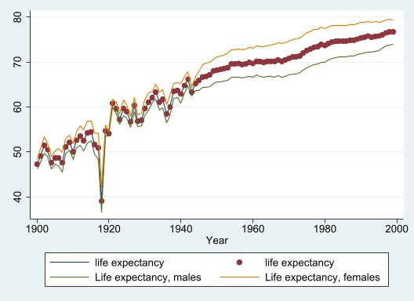

Figure 5.1

It appears that male and female life expectancies are largely correlated. While life expectancy for males remains slightly below female expectancy and the average life expectancy overall, it is usually only by 3-5 years or so.



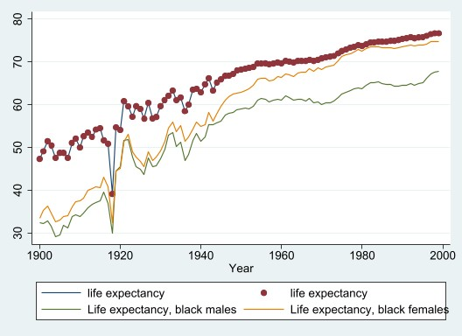

Figure 5.2

Life expectancy of black males and females is alarmingly lower than the average. Black males are again slightly lower in life expectancy than black females, particularly after 1960. At it’s peak, this difference reaches about 7 years.